Solutions for the Module 11 Exercise Problems
The exercise problems in Module 11 provide practice with falsify functional dependencies in sample rows and performing schema conversion and normalization together.

- For the big university database table, list FDs with the column StdCity as the determinant that are not true due to the sample data. For each FD, you should identify one falsification example or indicate that no falsification example exists in the sample rows. Remember that it takes two rows to falsify an FD in which the LHS is the same in both rows but the RHS is different.
Table 1: Sample Data for the Big University Database Table
StdNo | StdCity | StdClass | OfferNo | OffTerm | OffYear | EnrGrade | CourseNo | CrsDesc
s1 | seattle | jun | o1 | fall | 2013 | 3.5 | c1 | db
s1 | seattle | jun | o2 | fall | 2013 | 3.3 | c2 | vb
s2 | bothell | jun | o3 | SPRING | 2014 | 3.1 | c3 | oo
s2 | bothell | jun | o2 | fall | 2013 | 3.4 | c2 | vb

Answer
stdcity FDs and sample rows that falsify the FDs. The rows refer to the sample data above.

FD | Falsifications
StdCity → OfferNo | (1,2), (3,4)
StdCity → OffTerm | (3,4)
StdCity → EnrGrade | (1,2), (3,4)
StdCity → CourseNo | (1,2), (3,4)
StdCity → CrsDesc | (1,2), (3,4)
StdCity → OffYear | (3,4)
StdCity → StdNo | None
StdCity → StdClass | None

- You should add one or more sample rows to Table 1 for the FDs in problem 1 with no falsification example. For each non falsified FD with StdCity as the determinant, you should add one or more sample rows and then identify a falsification example involving the new row(s) and rows from Table 1.
Answer
FDs with stdcity as the determinant not falsified by Table 1 are listed below along with a reference to new rows (after row 4) that falsify the FDs.
stdcity → stdno is falsified by two pairs of rows: <1,5> and <2,5>
stdcity → stdclass is falsified by two pairs of rows: <1,5> and <2,5>

StdNo | StdCity | StdClass | OfferNo | OffTerm | OffYear | EnrGrade | CourseNo | CrsDesc
s1 | seattle | jun | o1 | fall | 2013 | 3.5 | c1 | db
s1 | seattle | jun | o2 | fall | 2013 | 3.3 | c2 | vb
s2 | bothell | jun | o3 | SPRING | 2014 | 3.1 | c3 | oo
s2 | bothell | jun | o2 | fall | 2013 | 3.4 | c2 | vb
S3 | SEATTLE | SR | O1 | FALL | 2014 | 3.3 | C1 | DB

- Convert the ERD in Figure 1 into tables and perform further normalization as needed. Your conversion result should show the list of tables with primary keys, foreign keys, and not null constraints. After converting the ERD to tables, specify FDs for each table. Since the primary key of each table determines the other columns, you should only identify FDs in which the LHS is not the primary key. If a table is not in BCNF, explain why and split it into two or more tables that are in BCNF.

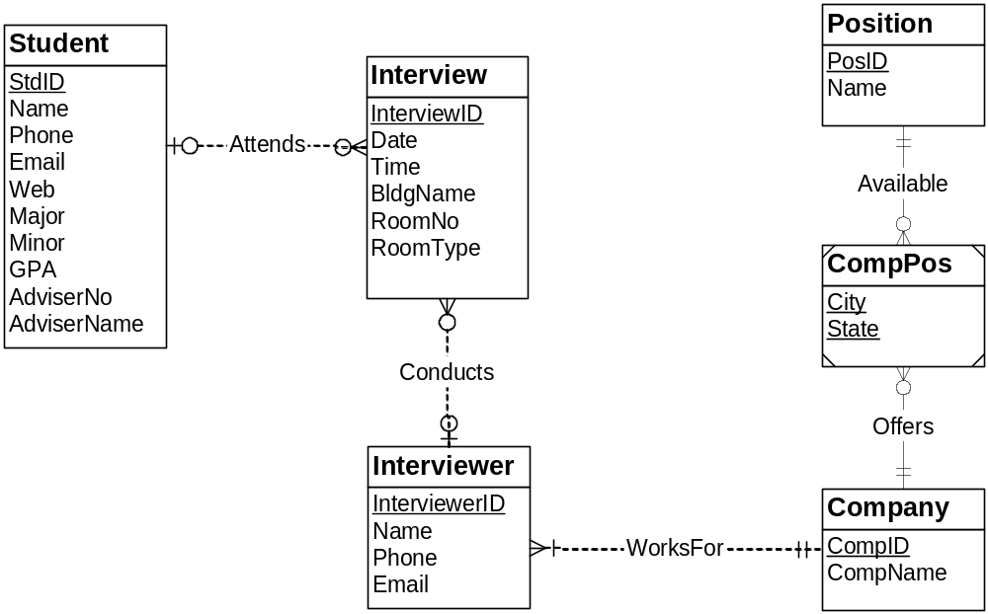
Figure 1: ERD for Problem 3
Result after conversion
Student(StdId, Name, Email, Phone, Web, Major, Minor, GPA, AdviserNo, AdviserName)

Interview(Interviewid, BldgName, RoomNo, RoomType, Date, Time, StdId, InterviewerId)
FOREIGN KEY(InterviewerId) REFERENCES Interviewer
FOREIGN KEY(StdId) REFERENCES Student

Interviewer(InterviewerId, Name, Phone, Email, CompId)
FOREIGN KEY(CompId) REFERENCES Company
CompId NOT NULL

Company(CompId, CompName)

Position(PosId, Name)

CompPos(CompId, PosId, City, State)
FOREIGN KEY(CompId) REFERENCES Company
FOREIGN KEY(PosId) REFERENCES Position

Further normalization
- The student table is not in BCNF because AdviserNo → AdviserName. If this FD is significant, split student into 2 tables with AdviserNo and AdviserName in a new table. AdviserNo is the primary key of the new table.
- The Interview table is not in BCNF because BldgName, RoomNo → RoomType. If this FD is significant split interview into 2 tables with BldgName, RoomNo, and RoomType in a new table. The combination of BldgName and RoomNo is the primary key of the new table.
- Another possible interpretation of the RoomNo attribute is that it contains both a building abbreviation and a room number. For example, PL212 means room 212 in the Plaza building. If RoomNo contains both a room number and a building abbreviation, then RoomNo→ BldgName, RoomType. If this FD is significant split the interview table into 2 tables with BldgName, RoomNo, and RoomType in a new table. The primary key of the new table is RoomNo.

- Apply the simple BCNF procedure to the following list of FDs. Show the result of each step. In the final list of tables, you should show the primary keys, foreign keys, and unique constraints. You do not need to write CREATE TABLE statements.
AuthNo → AuthName
AuthEmail → AuthNo
PaperNo → Primary-AuthNo
AuthNo → AuthAddress
AuthNo → AuthEmail
PaperNo → PapTitle
PaperNo → PapAbstract
PaperNo → PapStatus
RevNo → RevName
RevNo → RevEmail
RevEmail → RevNo
RevNo, PaperNo → Auth-Comm
RevNo, PaperNo → Prog-Comm
RevNo, PaperNo → RevDate
RevNo, PaperNo → Rating
RevNo → RevAddress

Step 1: Arrange the remaining FDs into groups by determinant

AuthNo → AuthName, AuthEmail, AuthAddress
AuthEmail → AuthNo
PaperNo → Primary-AuthNo, Title, Abstract, Status
RevNo → RevName, RevEmail, RevAddress
RevEmail → RevNo
RevNo, PaperNo → Auth-Comm, Prog-Comm, Date, Rating1, Rating2, Rating3,

Step 2: For each FD group, make a table with the determinant as the primary key. In the table list, the primary keys are underlined.

Author(AuthNo, AuthName, AuthEmail, AuthAddress)
FOREIGN KEY (AuthEmail) REFERENCES Author
AuthEmail(AuthEmail, AuthNo)
FOREIGN KEY (AuthNo) REFERENCES Author

Paper(PaperNo, Primary-AuthNo, Title, Abstract, Status)
FOREIGN KEY (Primary-AuthNo) REFERENCES Author
Reviewer(RevNo, RevName, RevEmail, RevAddress)
FOREIGN KEY (RevEmail) REFERENCES ReviewerEmail
ReviewerEmail(RevEmail, RevNo)
FOREIGN KEY (RevNo) REFERENCES Reviewer
Review(PaperNo, RevNo, Auth-Comm, Prog-Comm, Date, Rating1, Rating2, Rating3,
Rating4, Rating5)
FOREIGN KEY (PaperNo) REFERENCES Paper
FOREIGN KEY (RevNo) REFERENCES Reviewer

Step 3: Merge tables with the same columns. The Author and AuthEmail tables are merged. The Reviewer and ReviewerEmail tables are merged. UNIQUE constraints are added for AuthEmail and RevEmail.

Author(AuthNo, AuthName, AuthEmail, AuthAddress)
UNIQUE (AuthEmail)
Paper(PaperNo, Primary-AuthNo, Title, Abstract, Status)
FOREIGN KEY (Primary-AuthNo) REFERENCES Author
Reviewer(RevNo, RevName, RevEmail, RevAddress)
UNIQUE (RevEmail)
Review(PaperNo, RevNo, Auth-Comm, Prog-Comm, Date, Rating1, Rating2, Rating3,
Rating4, Rating5)
FOREIGN KEY (PaperNo) REFERENCES Paper
FOREIGN KEY (RevNo) REFERENCES Reviewer

